Assignment 3.2 - 2NF

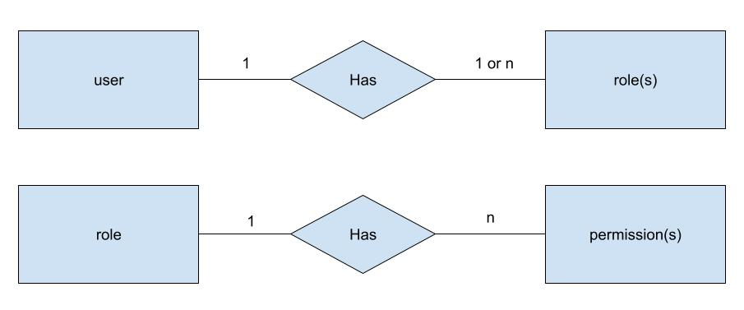

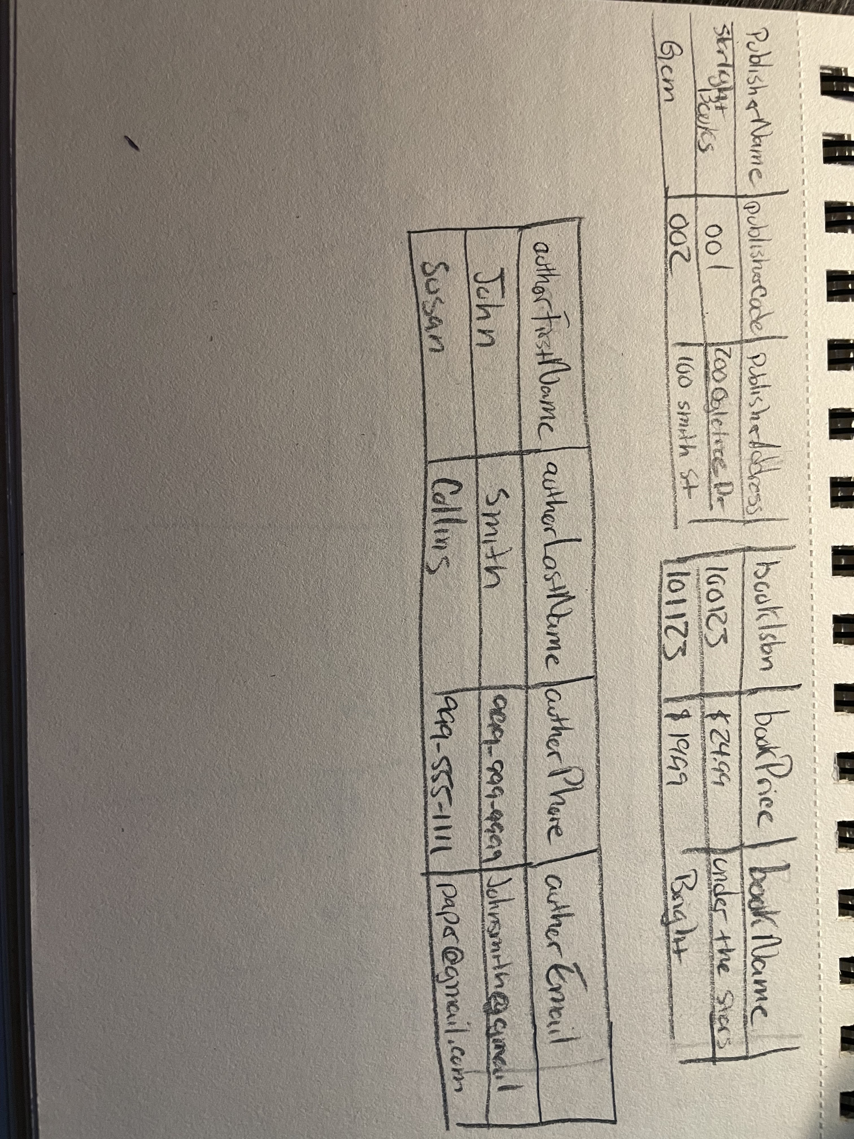

}

“publisherName”: “Starlight Books”,

“publisherCode”: “001”,

“publisherAddress”: “200 Ogletree Dr.”,

“bookIsbn”: “100123”,

“bookPrice”: “$24.99”.

“bookName”: “Under the Stars”,

“authorFirstName”: “John”,

“authorLastName”: “Smith”,

“authorPhone”: “999-999-9999",

“authorEmail”: “johnsmith@gmail.com”

}